Internal Assessment Resource
Mathematics and Statistics Level 1
EXPIRED
This resource supports assessment against:
Achievement Standard 91030 version 3
Apply measurement in solving problems
Resource title: TrapeziYUM Chocolate Bars
3 credits
This resource:
- Clarifies the requirements of the standard
- Supports good assessment practice
- Should be subjected to the school’s usual assessment quality assurance process
- Should be modified to make the context relevant to students in their school environment and ensure that submitted evidence is authentic

Date version published by Ministry of Education | February 2015 Version 2  To support internal assessment from 2015
Quality assurance status | These materials have been quality assured by NZQA.  NZQA Approved number A-A-02-2015-91030-02-4533
Authenticity of evidence | Teachers must manage authenticity for any assessment from a public source, because students may have access to the assessment schedule or student exemplar material.  Using this assessment resource without modification may mean that students’ work is not authentic. The teacher may need to change figures, measurements or data sources or set a different context or topic to be investigated or a different text to read or perform.

Internal Assessment Resource
Achievement Standard Mathematics and Statistics 91030: Apply measurement in solving problems
Resource reference: Mathematics and Statistics 1.5D v2
Resource title: TrapeziYUM Chocolate Bars
Credits: 3
Teacher guidelines
The following guidelines are supplied to enable teachers to carry out valid and consistent assessment using this internal assessment resource.
Teachers need to be very familiar with the outcome being assessed by Achievement Standard Mathematics and Statistics 91030. The achievement criteria and the explanatory notes contain information, definitions, and requirements that are crucial when interpreting the standard and assessing students against it.
Context/setting
This activity requires students to make calculations about trapezoidal chocolate bars and their production.
This activity could be adapted to any context that presents similar opportunities to meet the standard, for example, other packaging situations.
Conditions
This assessment is likely to take place over 1 – 2 periods of class time. Part 1 and Part 2 could be separated, with Part 2 being done the day after Part 1 so that students would not have to spend time in a test situation thinking of different designs. After the students have completed Part 1 (under test conditions), time could be spent in class discussing the context and the different types of shapes they could use to make their designs. The next day, the students would complete Part 2 independently during class time.
Resource requirements
Students need to be provided with a formulae sheet.
Additional information
None.

Internal Assessment Resource
Achievement Standard Mathematics and Statistics 91030: Apply measurement in solving problems
Resource reference: Mathematics and Statistics 1.5D v2
Resource title: TrapeziYUM Chocolate Bars
Credits: 3
Achievement | Achievement with Merit | Achievement with Excellence
Apply measurement in solving problems. | Apply measurement, using relational thinking, in solving problems. | Apply measurement, using extended abstract thinking, in solving problems.
Student instructions
Introduction
This activity requires you to design a number of different chocolate bars for Hurley’s Chocolate Company.
You will be assessed on your depth of understanding and application of measurement. It is important you communicate your thinking and your solutions clearly and relate your findings to the context.
You will have <teacher to insert time and conditions here>.
Task
Chocolate bar design
Hurley’s Chocolate Company has decided to make a new range of mathematically shaped chocolate bars.
Your task is to design a range of chocolate bars for Hurley’s and compare them with their new TrapeziYUM design.

Part 1
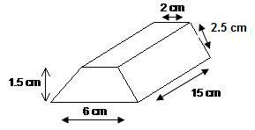
The new TrapeziYUM chocolate bar is designed to fill a package of the same shape.
This is a sketch of the package.

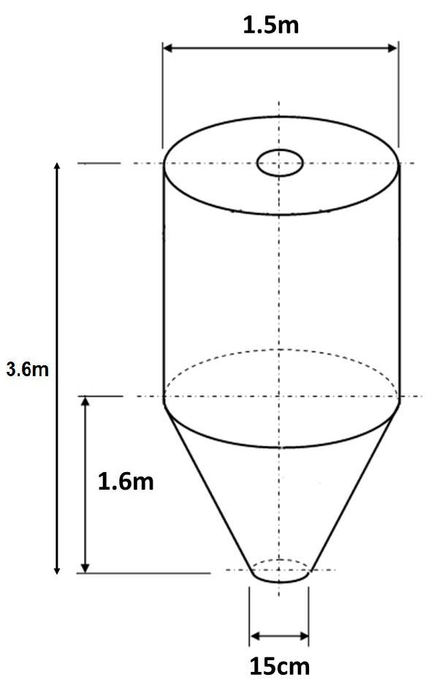

Hurley’s can make a batch of chocolate bars using chocolate from their vat.
A diagram of the vat is shown here.

One litre of the chocolate used to make the bars costs $3.50.

Hurley’s wants to know:
- how much chocolate is needed to make one new TrapeziYUM bar
- how much it will cost to make one new TrapeziYUM bar
- how many new TrapeziYUM bars can be made from a full vat of chocolate.

Part 2
Design different chocolate bars for Hurley’s. They need to meet the specifications stated below. Compare your new designs with the new TrapeziYUM design. Recommend to Hurley’s which chocolate bar(s) they should produce.
Note: The vat (shown above) is to be used in the production of all the chocolate.
Their specifications are:
- All the bars must fit inside the new TrapeziYUM package, but the bars themselves can be any kind of shape.
- They would like a number of different mathematical shapes (suggestions from the manager of the company include pyramid shapes, half-cylinder shapes, and more).
Your answer should include the volume of each bar, the number of bars that can be made from a full vat of chocolate, costs, and your final recommendations to Hurley’s.

Formulae sheet

Area of circle = πr²

Circumference of circle = πd

Area of trapezium =

Area of parallelogram =

Area of triangle =

Volume of prism = base area × h

Volume of pyramid = $\frac{1}{3}$ base area × h

Volume of cylinder =

Volume of cone = $\frac{1}{3}$

Volume of sphere = $\frac{4}{3}$

Surface area of sphere = 4πr²

Assessment schedule: Mathematics and Statistics 91030 TrapeziYUM Chocolate Bars
Evidence/Judgements for Achievement | Evidence/Judgements for Achievement with Merit | Evidence/Judgements for Achievement with Excellence
Applying measurement in solving problems will involve:  - selecting and using a range of methods in solving problems  - demonstrating knowledge of measurement concepts and terms  - communicating solutions that would usually require only one or two steps.  Evidence of at least three different methods is required.  For example, for the new TrapeziYUM bar:  - correct use of units in measurements and calculations  - finding the volume of the new TrapeziYUM bar (trapezium-based prism)  - finding the volume of parts of the chocolate vat.  Other evidence could be found in designs the student has developed that take the dimensions of the package into consideration, for example, they could have square-based pyramids next to each other.  Note: The volume of a cuboid would not provide evidence of a method relating to volumes.  The solutions must be communicated clearly and must be in context. | Applying measurement, using relational thinking, in solving problems will involve one or more of:  - selecting and carrying out a logical sequence of steps  - connecting different concepts and representations  - demonstrating understanding of concepts  - forming and using a model  And also relating findings to a context, or communicating thinking using appropriate mathematical statements.  For example, a logical sequence of steps could be: finding the volume of the new TrapeziYUM bar, finding the volume of the chocolate vat, and calculating the number of new TrapeziYUM bars that can be made from a full vat of chocolate.  The student could have also shown a logical sequence of steps and formed a model when they designed their own chocolate bar. This is likely to include showing that their own bar fitted in the new TrapeziYUM package by calculating the number of their own bars that can be made from a full vat of chocolate and comparing this with the number of new TrapeziYUM bars that can be made from a full vat of chocolate. | Applying measurement, using extended abstract thinking, in solving problems will involve one or more of:  - devising a strategy to investigate or solve a problem  - identifying relevant concepts in context  - developing a chain of logical reasoning, or proof  - forming a generalisation  And also using correct mathematical statements, or communicating mathematical insight.  The student has developed and evaluated different designs of their own chocolate bars for Hurley’s by:  - designing their own bars, which fit the given package  - calculating with a table or something similar the numbers of bars that can be made from a full vat of chocolate for both the given bars and their own designs  - comparing volumes, numbers of bars, or costs  - making a final recommendation to Hurley’s, supported by a discussion/evidence that supports the different designs in terms of the process undertaken.
Final grades will be decided using professional judgement based on a holistic examination of the evidence provided against the criteria in the Achievement Standard.

